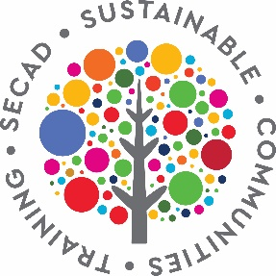

SECAD Sustainable Communities Training Programme
Application Form 2021

This application form is for communities to apply to be part of the free SECAD Sustainable Communities Training Programme which will take place from September 2021 to September 2022
Ideally, you should speak with other community members / groups to see if they would like to collaborate as part of a Community Development Team for your area, however, if we receive applications from individuals we reserve the right to link groups together to strengthen an application.
The information on this form will be used by SECAD and the Sustainable Communities Training Programme trainers to inform you about the programme

Section 1: Community Details

Community Name
Community group or groups (if applicable)
Does your community have a community plan which you want to update or do you want to develop a new plan
Is this the first time your community is developing a community plan?
What are the top three priorities in your community currently | Don’t know

Section 2: Contact Details of person completing form

Name
Community group (if applicable)
Address
Phone Number
Email

Section 3: Community Objectives
Please outline what community groups / individuals have committed to being part of your Community Development Team (ideally 10 to 15 people).
Sectors may include community facilities, business owners, environment, youth, education, active age, disability, new communities, LGBTQI+, tourism, recreation and more
Do you need assistance in recruiting your Community Development Team (of 10 to 15 people)
Please outline the key objectives for your community in taking part in this training programme.
What are your anticipated outcomes for participating in the Sustainable Communities Training Programme?

Signed: __________________________ Date: ______________________________

Eligibility Criteria
Communities that wish to participate in this training programme must satisfy the following criteria:
- Be based within SECAD’s LEADER operational area (you can check eligible areas on these links):
  - https://leadersouthcork.com/index.php/find-local-development-company/
  - https://leaderwestcork.com/index.php/find-local-development-group/
- Commit to collaborate as a team (Community Development Team) in your community and to participate in the SECAD Sustainable Communities Training Programme (approximately once a week) from September 2021 to June 2022.

Thank you for your interest in this programme.

If you have any queries, please contact Nuala O’Connell at SECAD
on 021 4613432 / 087 9672515

Please return this completed application form by Friday 11th June to noconnell@secad.ie

